[**CREATE AND CONFIGURE IBM CLOUD SERVICES**](https://careereducation.smartinternz.com/Student/guided_project_workspace/14105#collapse3)

**CREATE NODERED SERVICE**

|  |  |
| --- | --- |
| **TEAM ID** | **PNT2022TMID08369** |
| **PROJECT NAME** | **IOT BASED SMART CROP PROTECTION SYSTEM FOR AGRICULTURE** |

STEP 1:

First login your IBM cloud account using <http://cloud.ibm.com> URL.

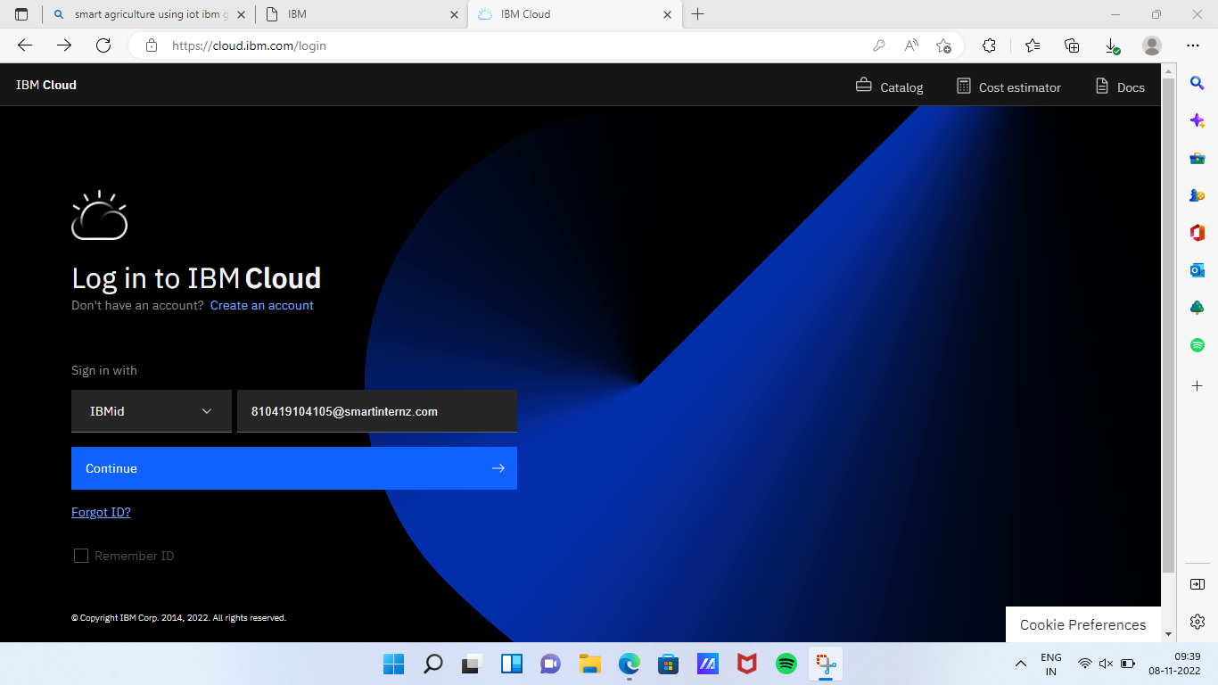

STEP 2:

Then open resource list tab and open Node Red YYCHD 2022-10-08 in Compute. And open [node-red-yychd-2022--cloudant-1665242487602-27348 open this link.](https://cloud.ibm.com/services/cloudantnosqldb/4a3f98e7-9f85-423d-b52e-d90aff5c6232?env_id=ibm:yp:eu-de" \t "_blank)

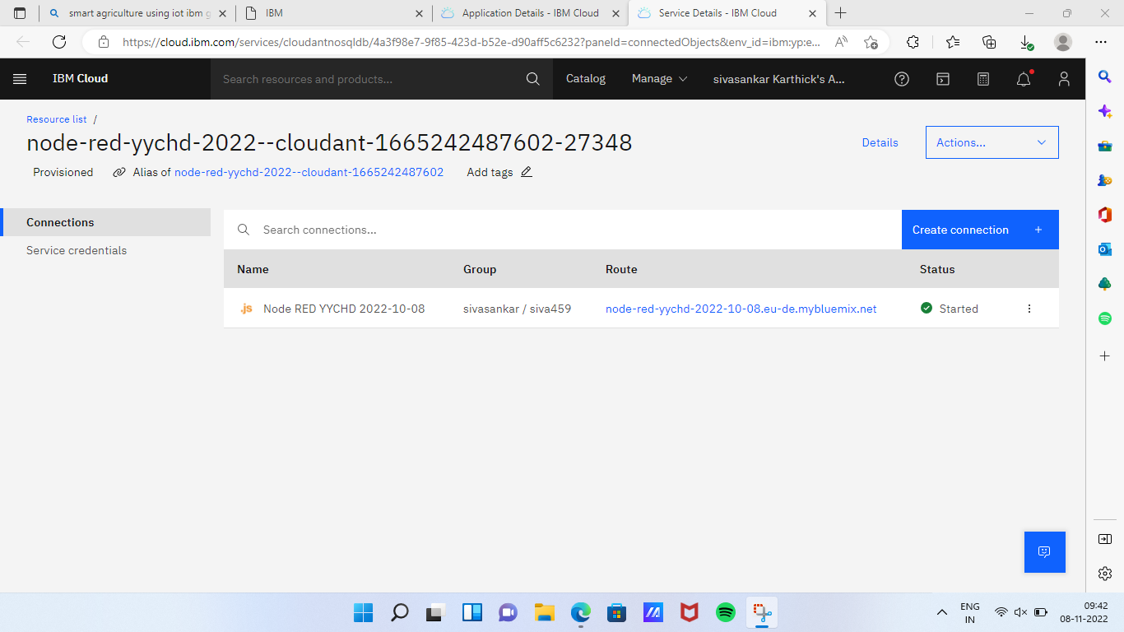

STEP 3:

[node-red-yychd-2022-10-08.eu-de.mybluemix.net](https://node-red-yychd-2022-10-08.eu-de.mybluemix.net/) open this link it redirects Node-RED on IBM cloud.

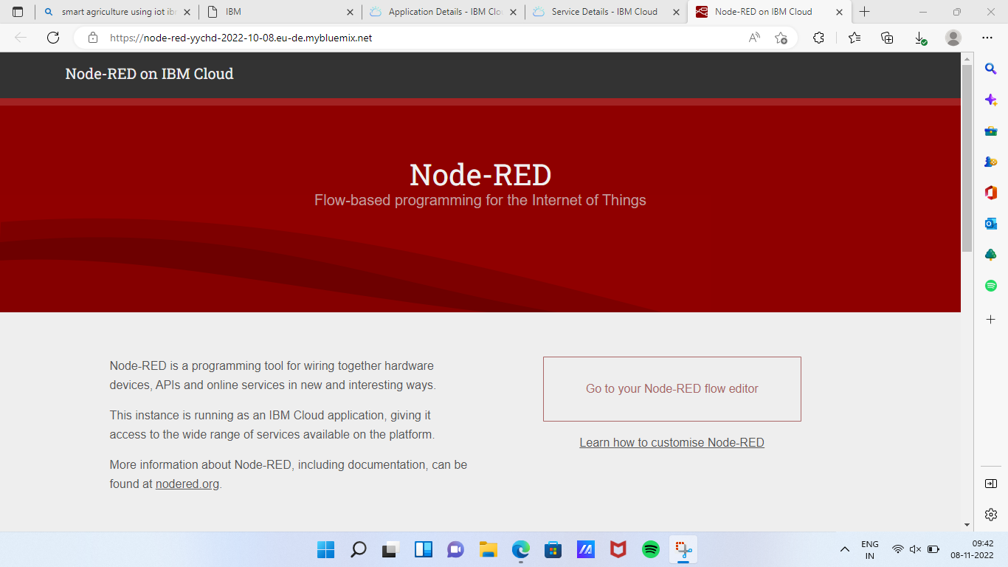

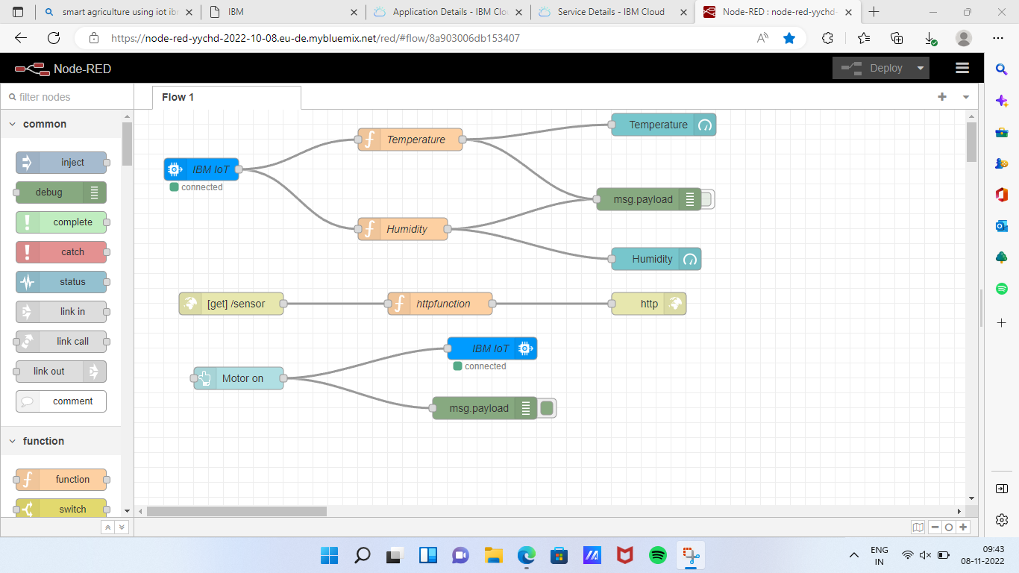

STEP 4:

Type this link in browser [node-red-yychd-2022-10-08.eu-de.mybluemix.net](https://node-red-yychd-2022-10-08.eu-de.mybluemix.net/)/ui

This page shows the user interface of your Node-RED flow editor.

